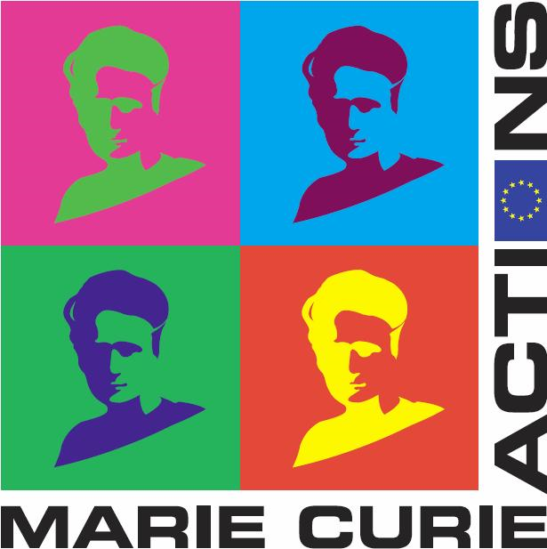

ITN Marie Curie
Workshop
« Stochastic Control and Finance »

Roscoff, March 18-23 - 2010

REGISTRATION FORM

Deadline for the registration: 30/11/2009

Name: First Name:

Organisation:

Function:

Address:

Phone number: Fax:

Email:

◻ Participation at the Workshop from 18th at 23rd of March 2010 (5 days)

Date of arrival: Date of departure:

- Do you have the intention to give a talk?

- Yes No

Please send us the registration form at the following address: fanny.buannic@univ-brest.fr
.

